Fundamentals of Database Technologies

Assignment 5

Name: Qian Zhang

CID: 01939418

Date: 22/10/2020

Question 4

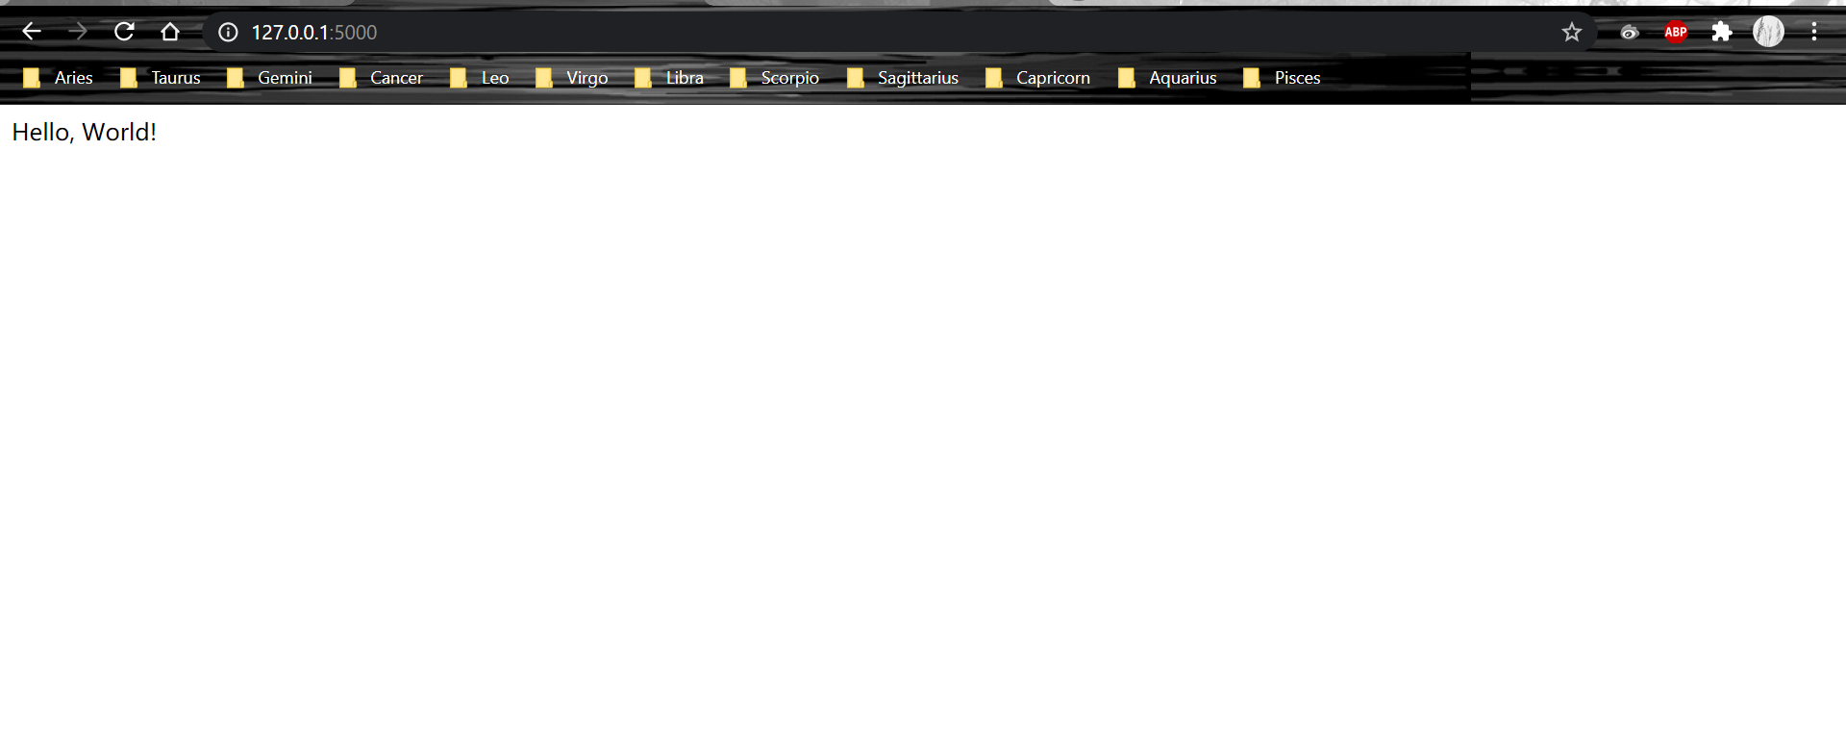

Question 5:

I turn on the debugger mode using the code

set FLASK_DEBUG = 1



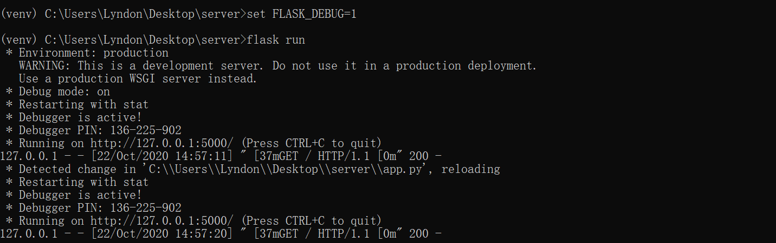

Question 6

app.py

from flask import Flask,render_template

app = Flask(__name__)

@app.route('/')

def base():

return render_template('base.html')

base.html

<!DOCTYPE html>

<html>

<body>

<h1>Fundamentals of Database Technologies</h1>

<p>Assignment 5</p>

</body>

</html>



Question 11

